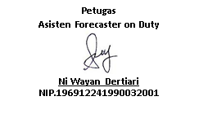
Forecaster on Duty

I Made SudarmaYadnya, S.Si
NIP. 19810322 200701 1 013

Dibuat Oleh:
Forecaster on Duty
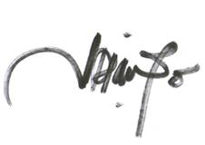
Kd.Diana Anggariati,SP
NIP.196705231990032002

Forecaster on Duty
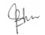
TirthaWijaya,SP
NIP.197312051995031001

Dibuat Oleh:
Forecaster on Duty

A.A.Putu Eka Putra Wirawan
NIP. 198212232006041002

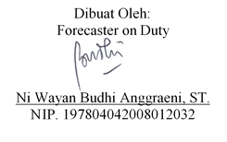
Forecaster on Duty

Ni Putu Lia Cahyani, SP
NIP.198503012007012003

Forecaster on Duty
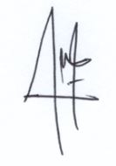
Diana Hikmah, S.Tr
NIP.199202132012102001

Forecaster on Duty
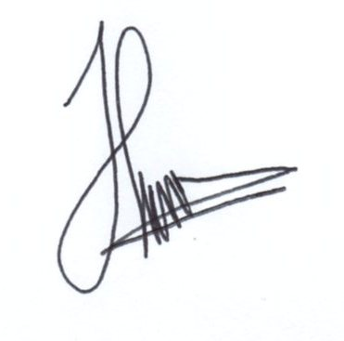
I Wayan Wirata, S.Tr
NIP. 199111062013121001

Forecaster on Duty

Brian Eko Permadi
NIP. 199209232012101001

Forecaster on Duty
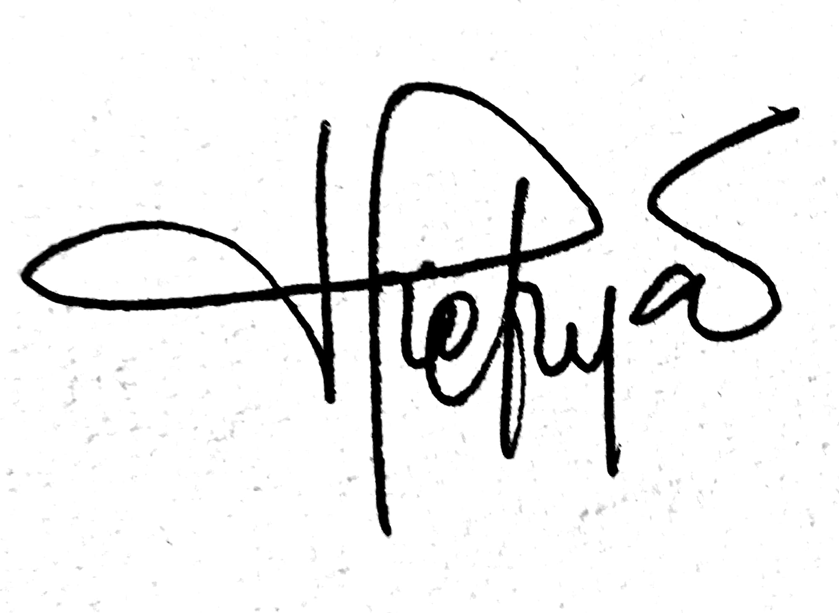
Kadek Setiya Wati, S.Tr
NIP. 198906032010122002

Forecaster on Duty
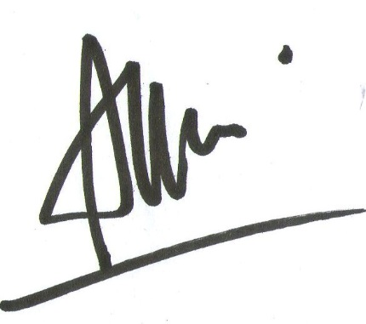
Luh Eka Arisanti, S.Si
NIP. 198909272010122001

Forecaster on Duty
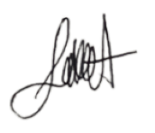
I Wayan Gita Giriharta
NIP. 199604012016011001

Forecaster on Duty

Putu Agus Dedy Permana, S. Tr
NIP. 199308092013121001

Dibuat oleh :
Forecaster on Duty
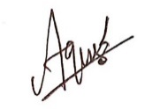
I Gede Agus Mahendra
NIP. 199304282013121001


Dibuat oleh :
Forecaster on Duty
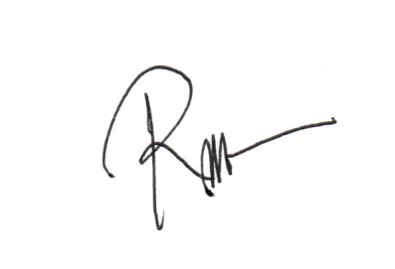
Rizki Dwi Saputro, S.Tr
NIP. 199308272013121001

Dibuat Oleh:
Forecaster on Duty
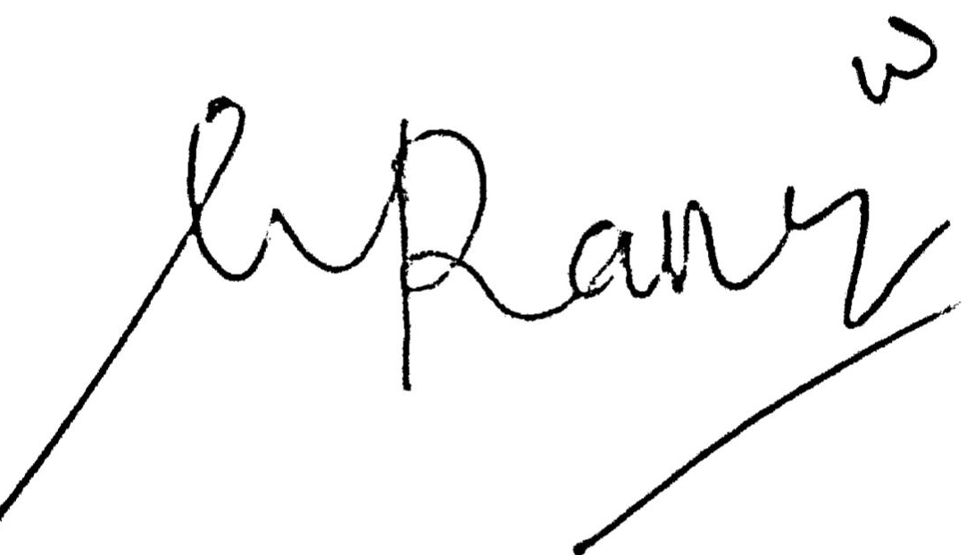
Wulan Wandarana, S.Tr
NIP. 199505142014112001

c
Dibuat oleh :
Forecaster on Duty

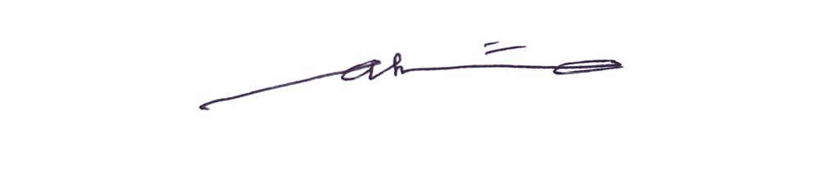
I Gusti Ayu Putu Putri Astiduari, S.Tr
NIP. 199308182013121001

Forecaster on Duty

Wulan Wandarana, S.Tr
NIP. 199505142014112001

Forecaster on Duty

Wulan Wandarana, S.Tr
NIP. 199505142014112001

